ABDD7311

Practical assignment 1

ST10359034

Emil fabel

1. 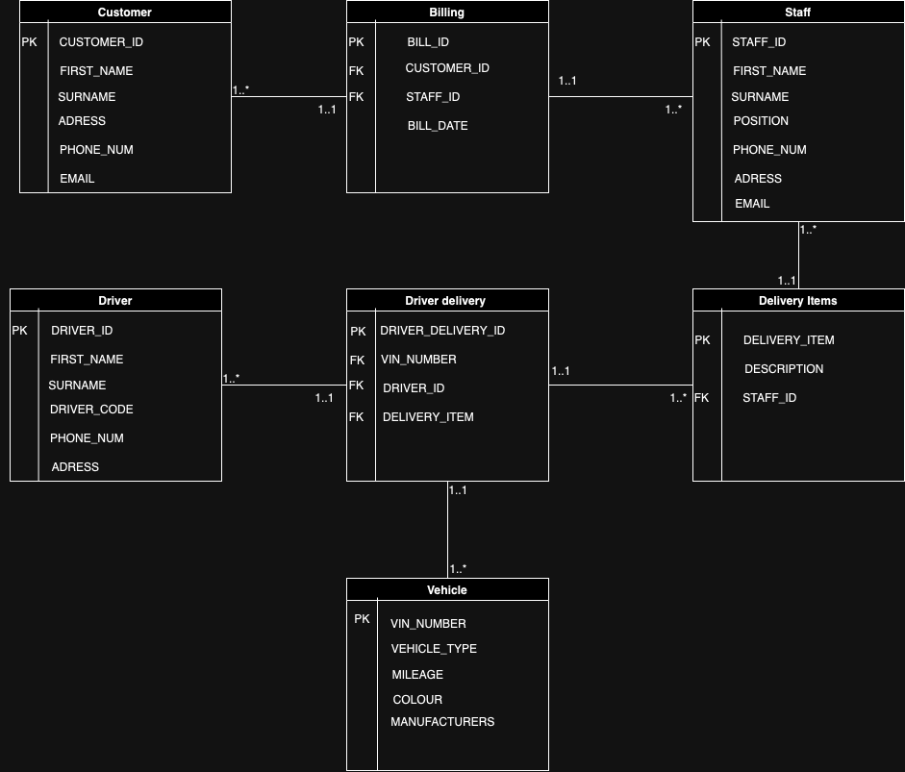ERD Diagram

Q2. Tables Creation

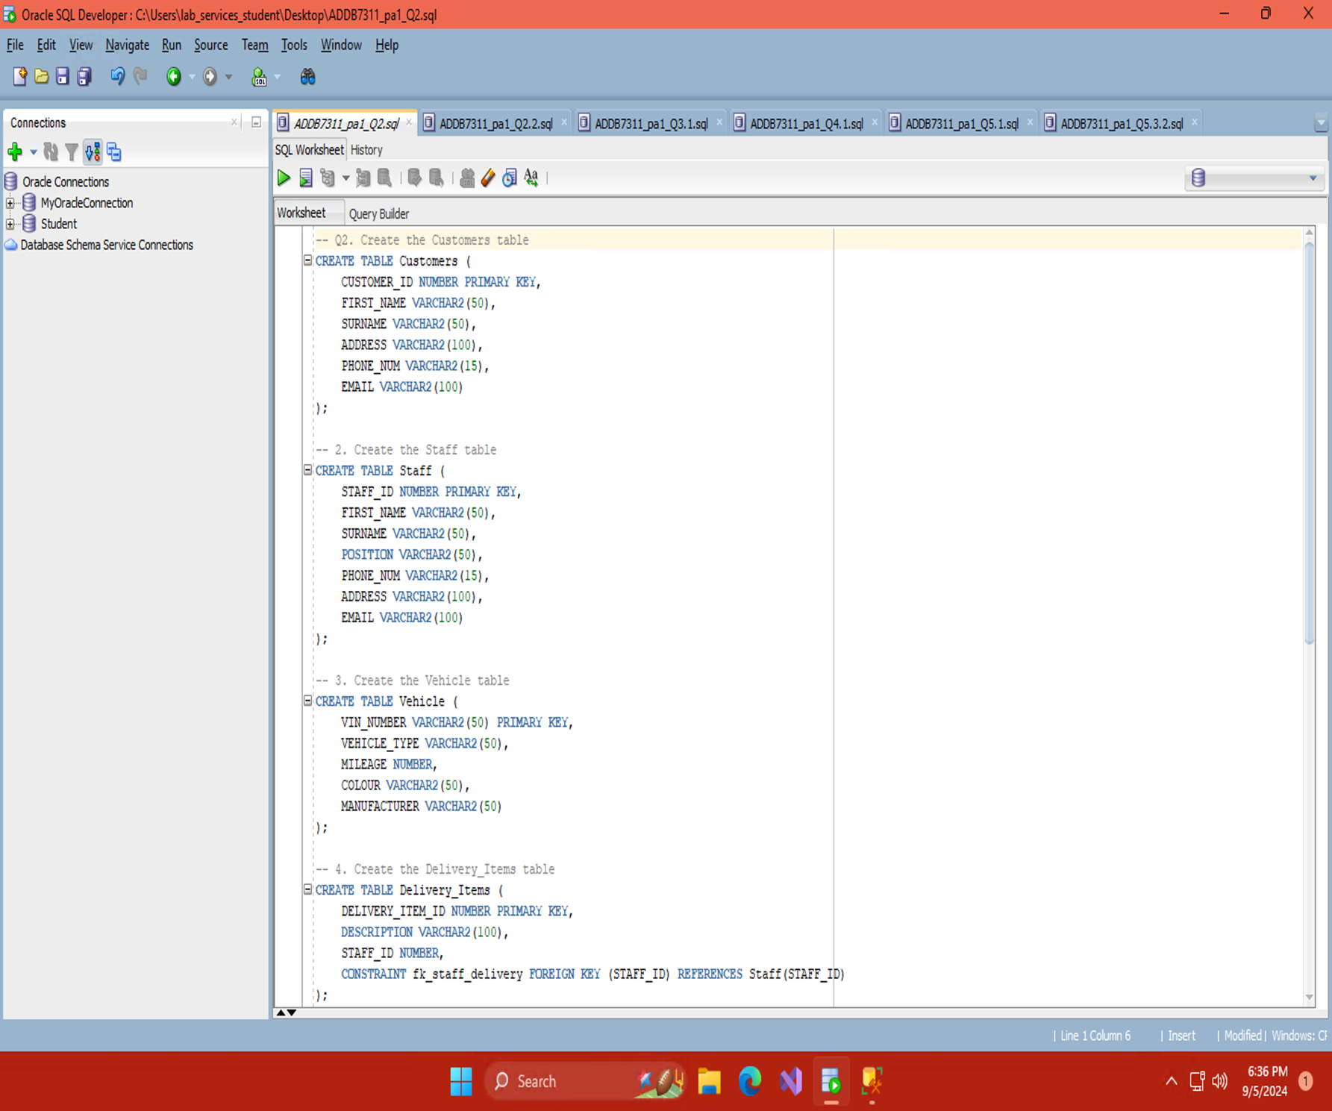

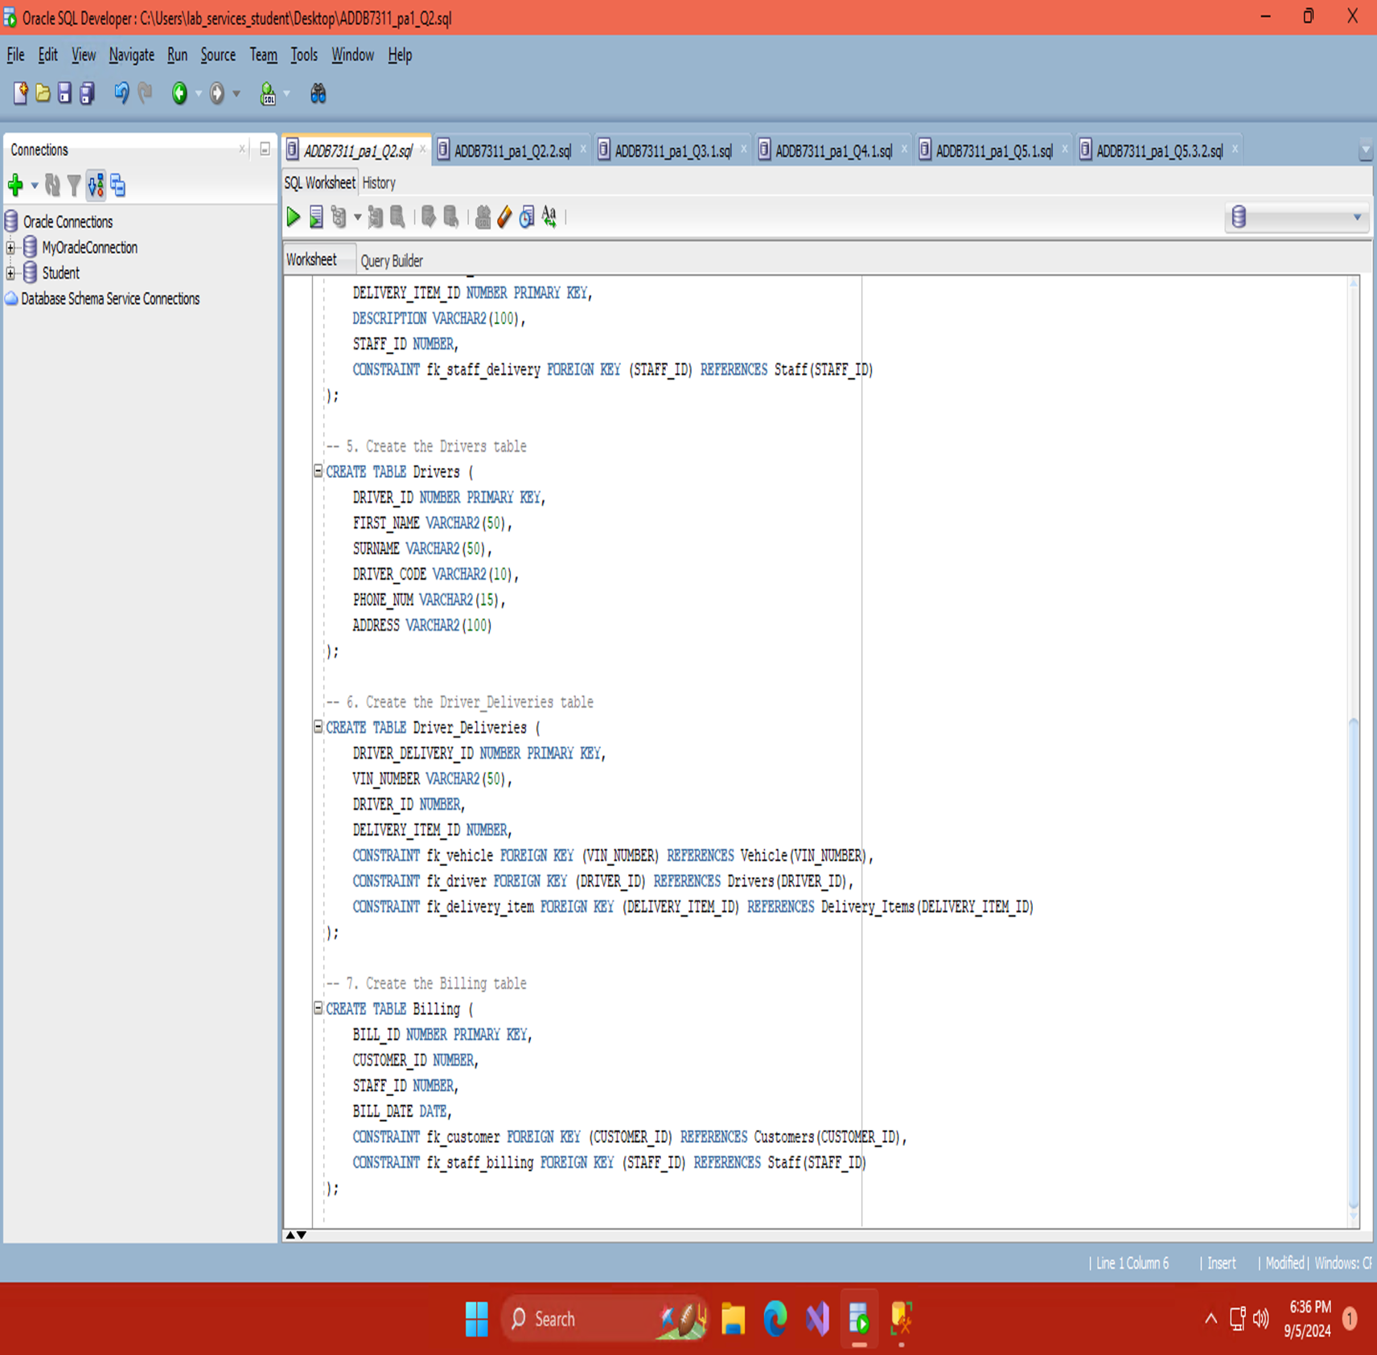

Import of Data Into Created Tables

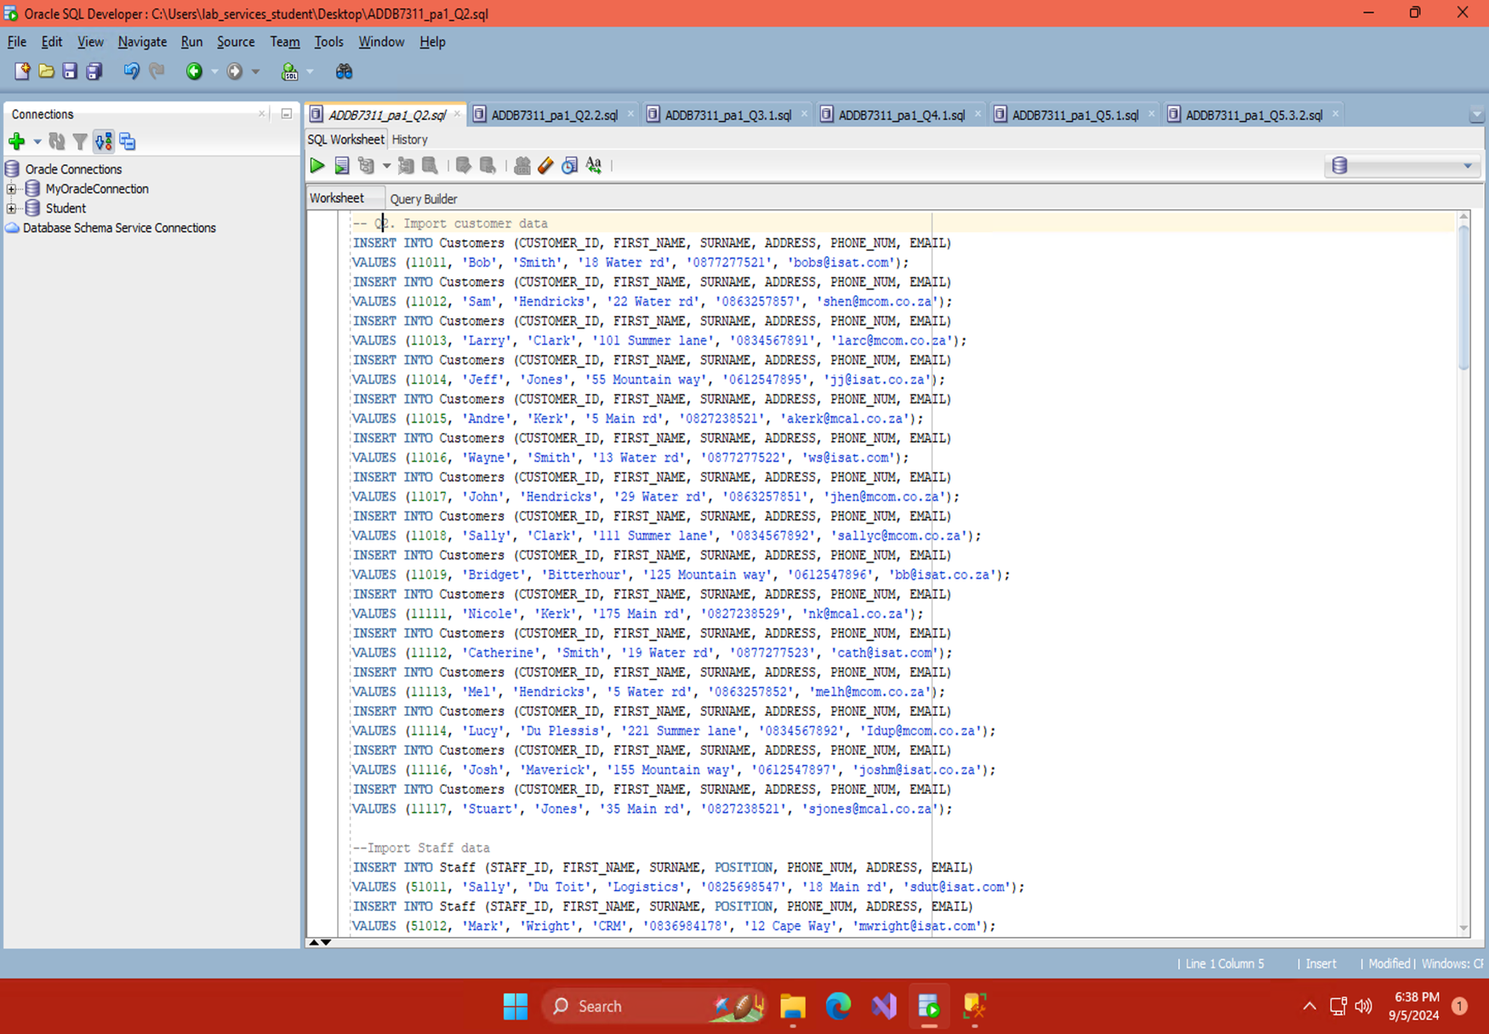

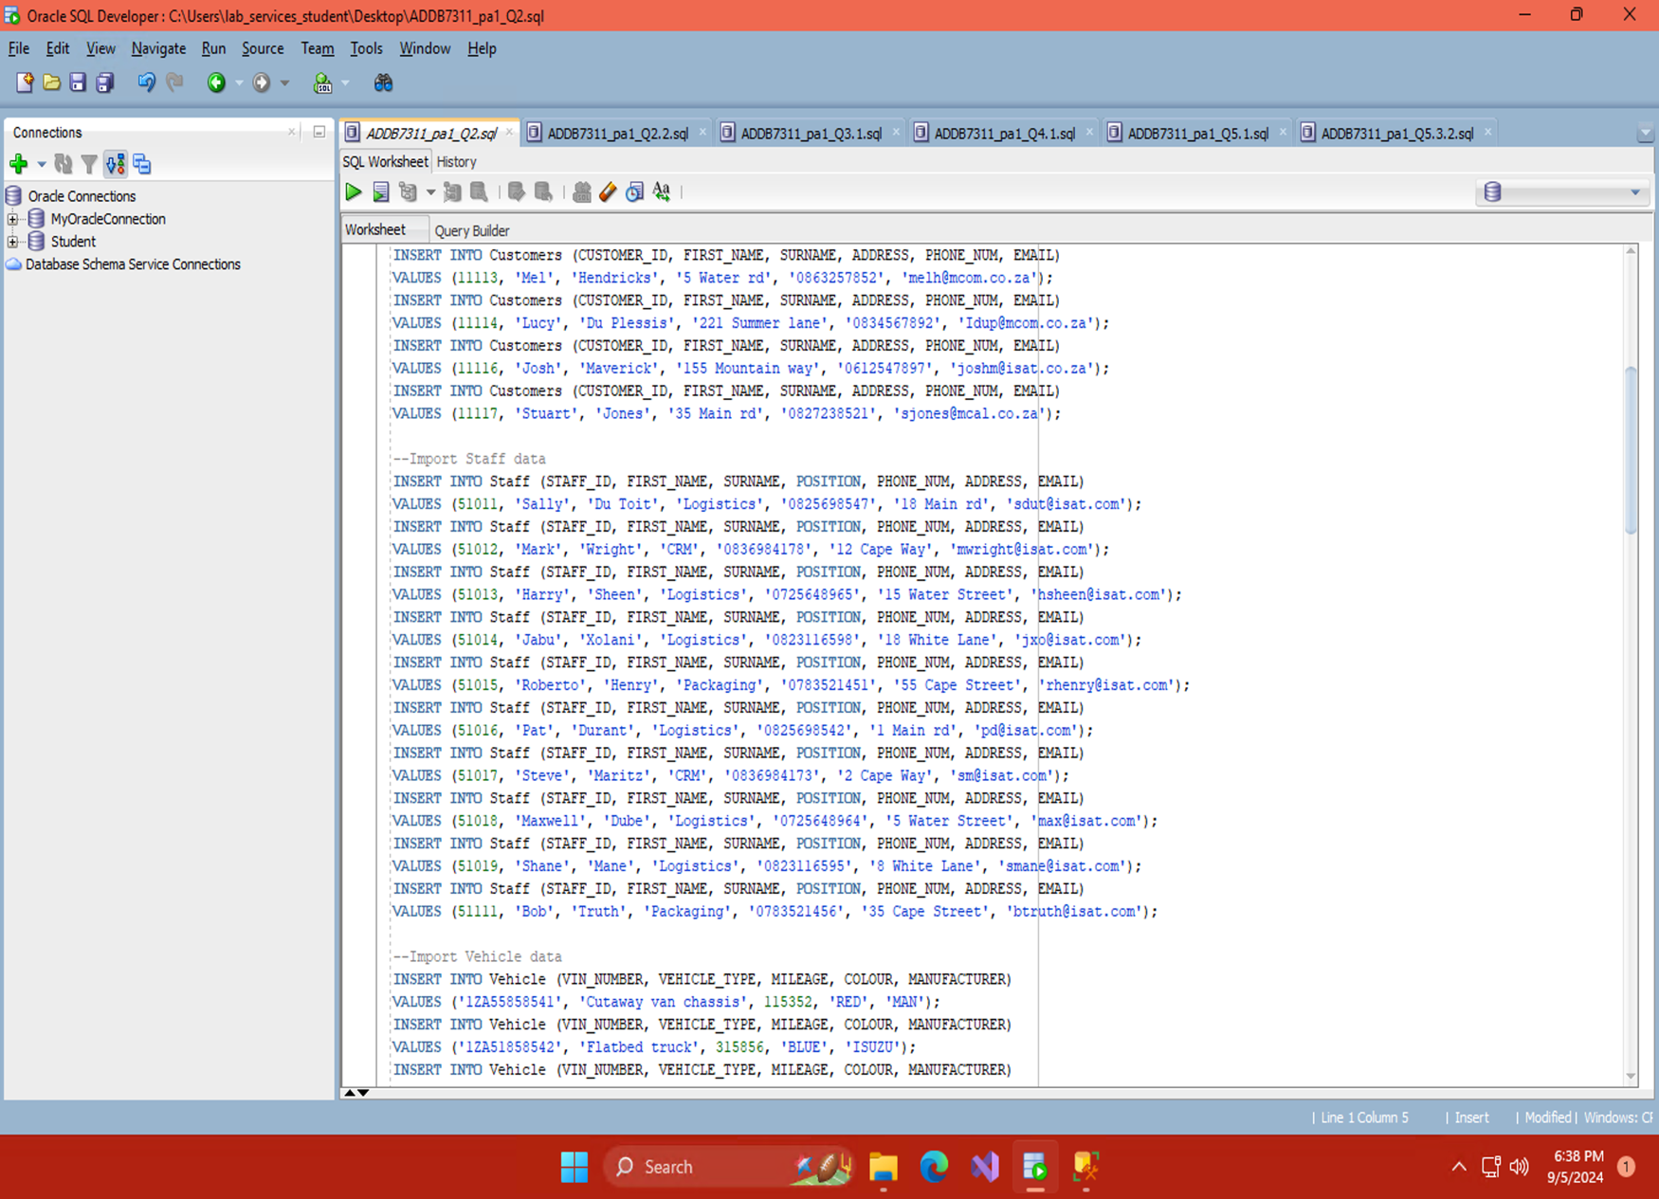

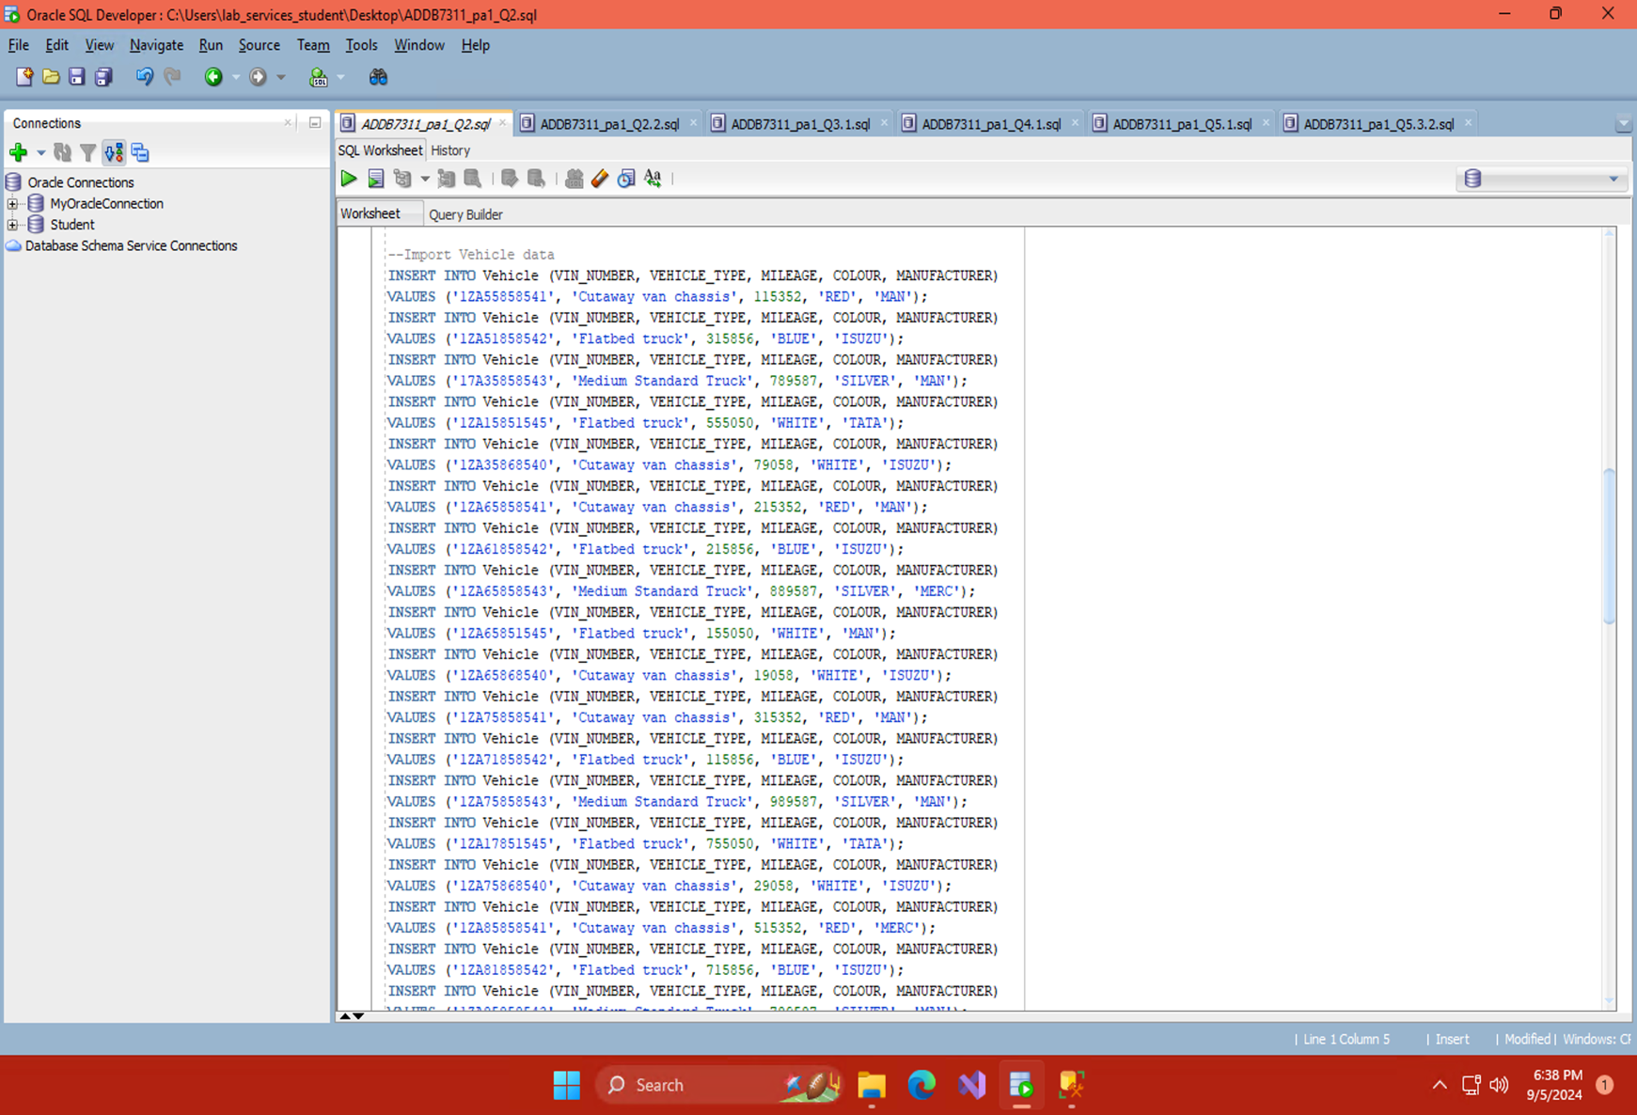

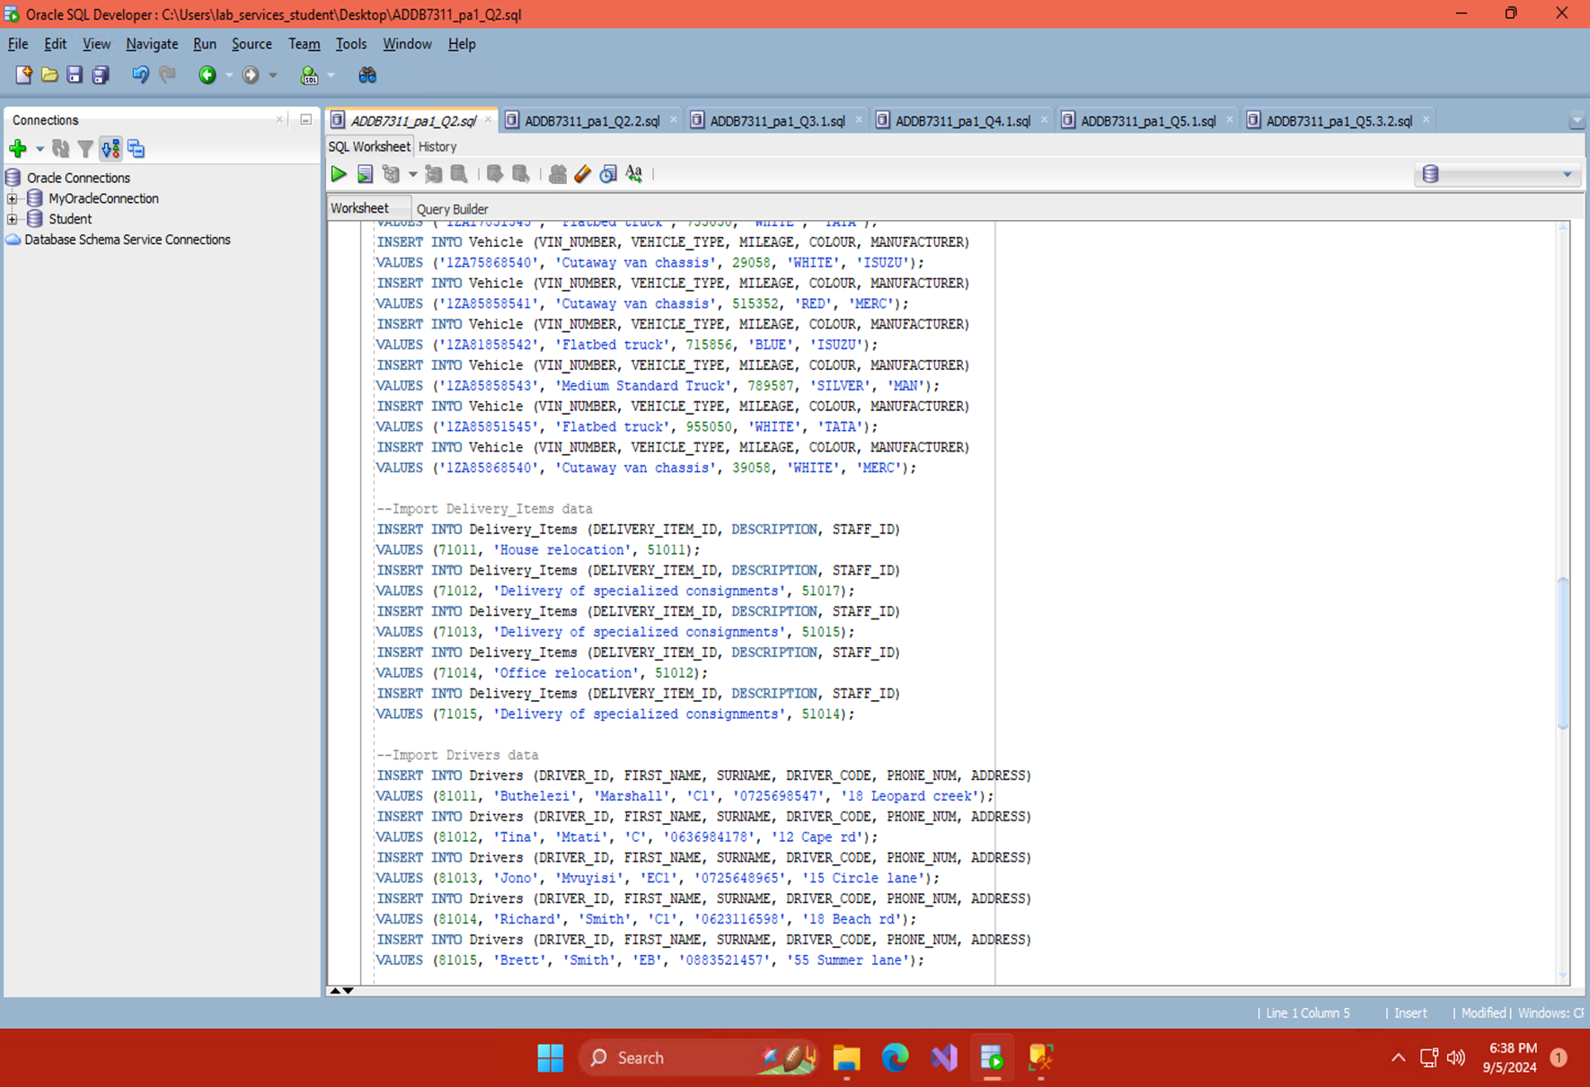

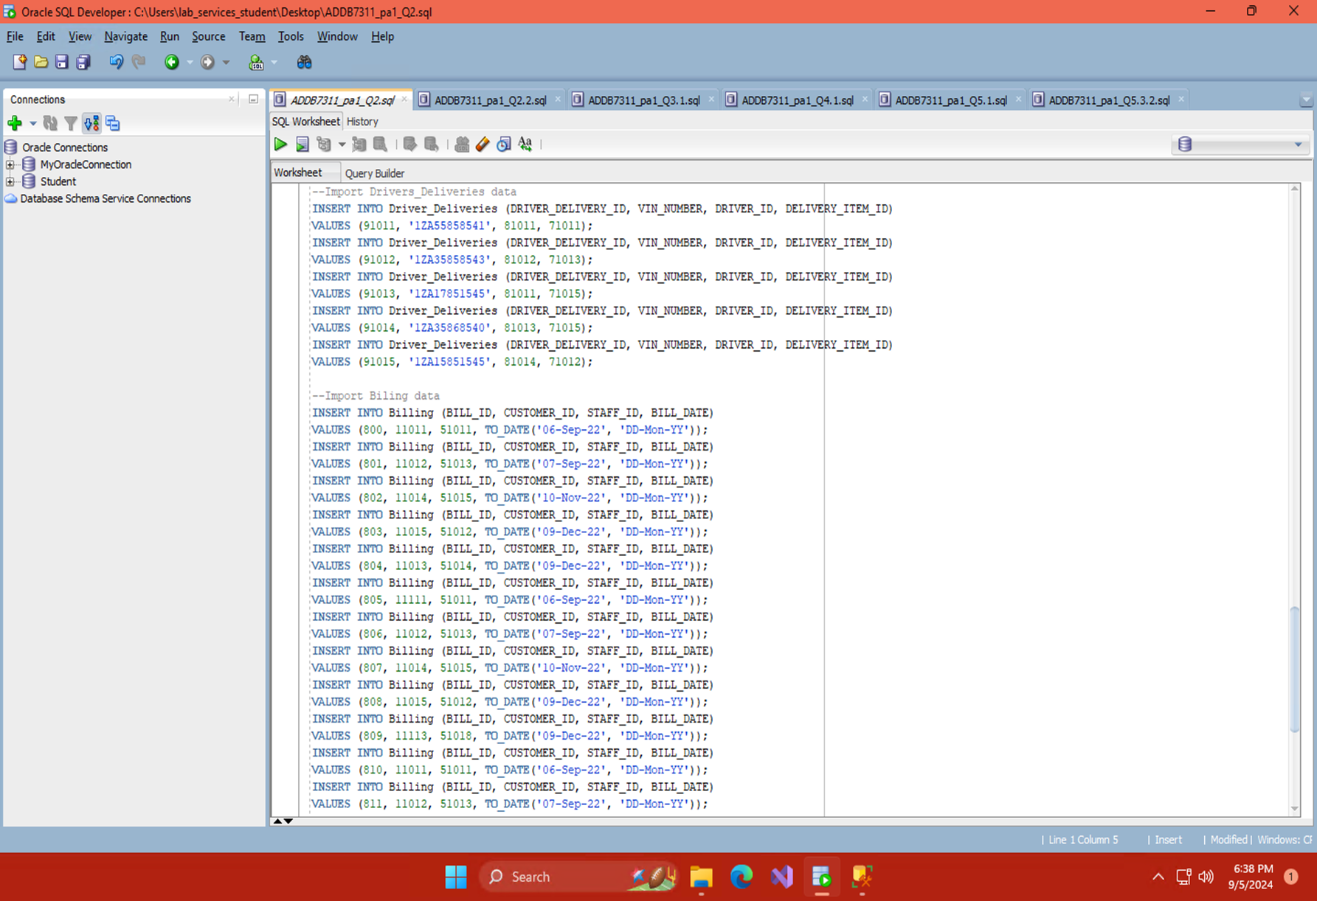

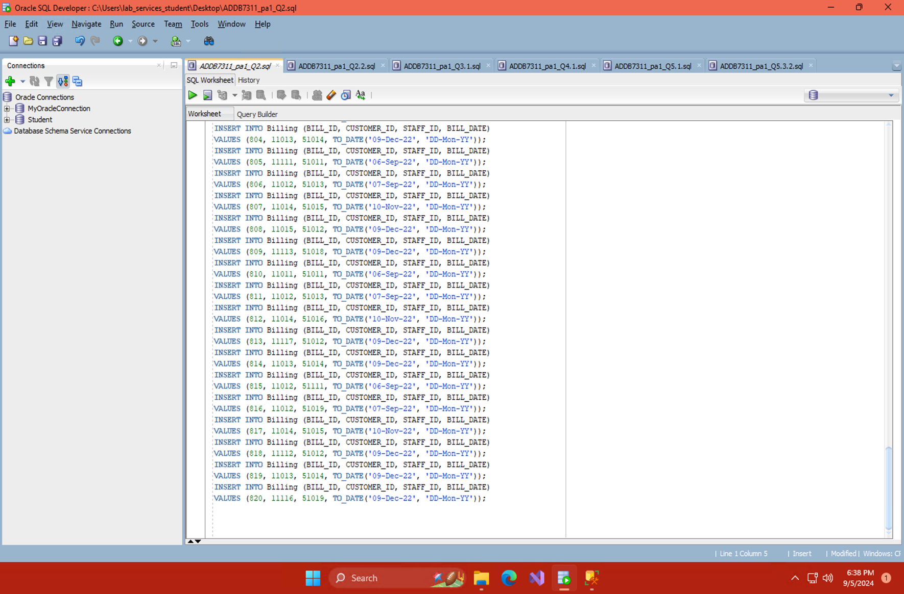

Q3.1 Creating and Granting Privileges To Users

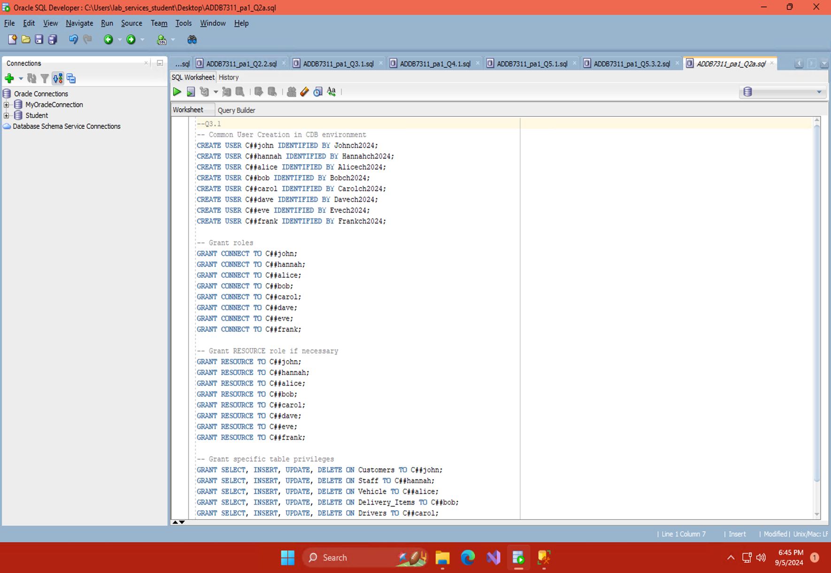

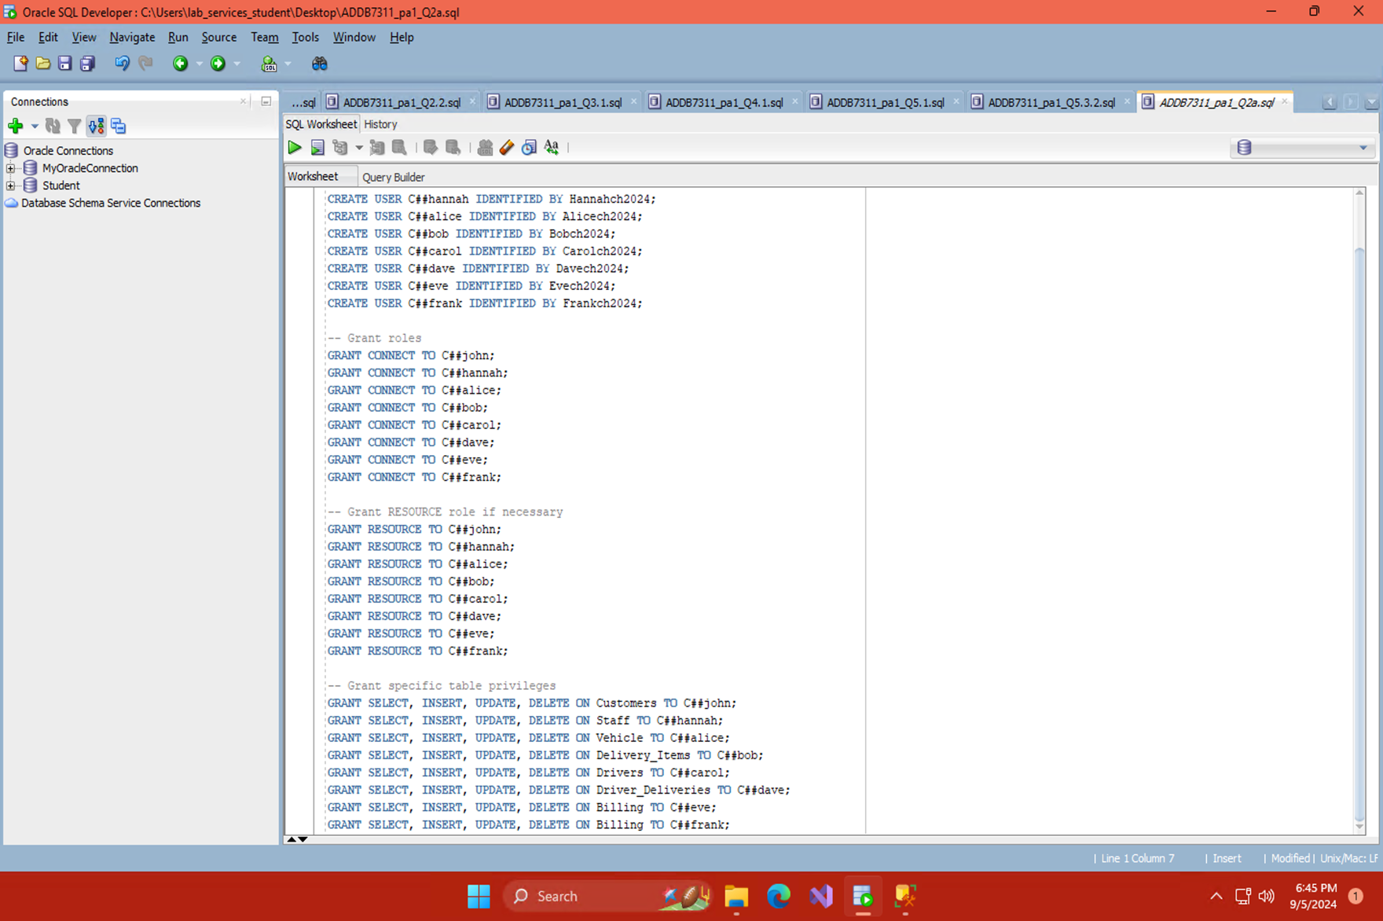

Q3.2

Importance of Separation of Duties

Separation of duties is crucial for security and data integrity. It lowers the possibility of accidental or deliberate data breaches or misuse by guaranteeing that no single person has complete control over a system's functions. To provide checks and balances in database usage, "John" may be in charge of data retrieval and "Hannah" of data input.

(Imperva, 2024)

Q4.1 Driver Report of Vehicle with Lower than 80000 Miles

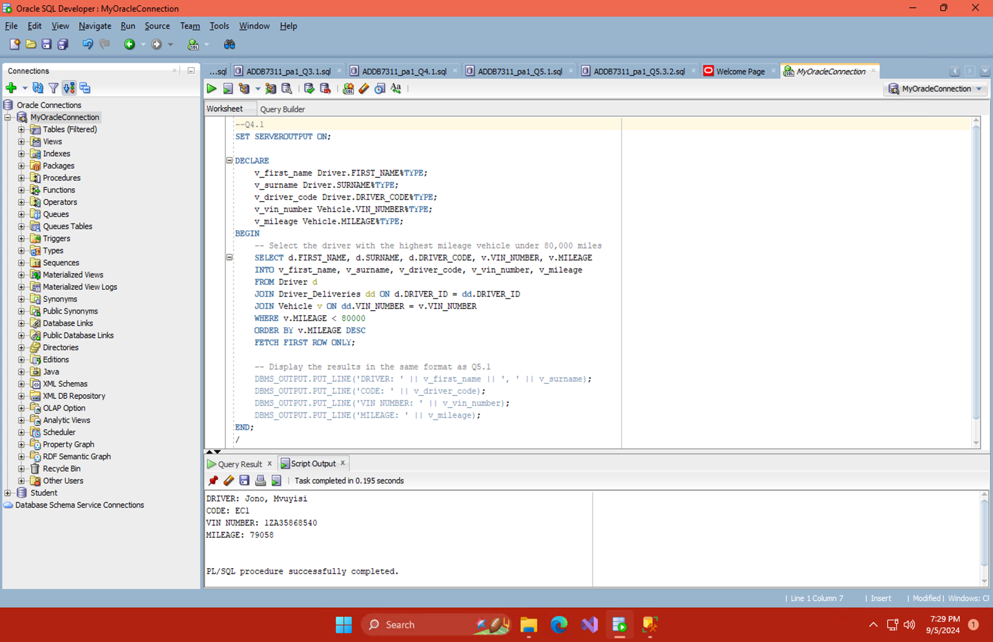

Q4.2

Flat File Database Model:

Simplicity: For small applications, setting up a single table or file containing all the data is simple.

Data redundancy: Since everything is stored in one location, there is a high chance of duplicate data.

Limited Query Capabilities: It can be hard to manage relationships or run sophisticated queries.

Data Integrity: Because there are no restrictions, it is difficult to keep correct and consistent data.

Relational Database Model:

With structured data management, redundant information is cut down on and consistency is enhanced by grouping data into related tables.

Complex Queries: This feature is essential for evaluating driver performance or customer interactions as it allows complex queries to link data and obtain detailed insights.

Data integrity reduces anomalies and ensures data accuracy by enforcing restrictions and connections.

Scalability: The ability to effectively handle expanding volumes of data and adjust to changing business requirements.

(Guldenpfennig, 2023) (IBM, 2022) (Hughes, et al., 2024)

Q5.1 Report of Staff Who Has Processed Most Deliveries

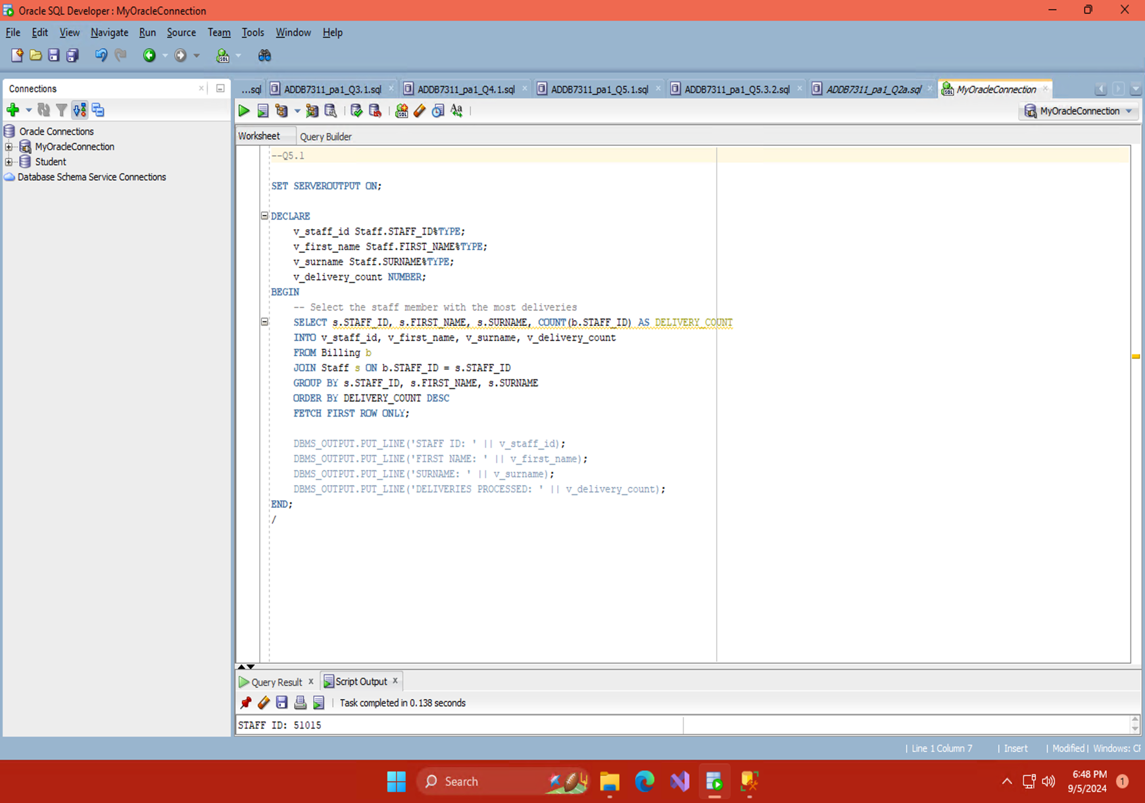

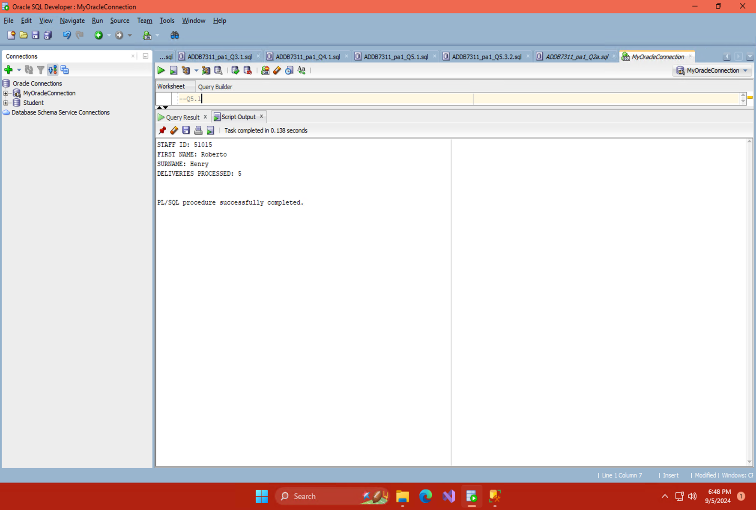

Q5.2

**Explanation of PL/SQL Components**

Declaration:

Declares variables to store data fetched from the database. As shown under "DECLARE"

Execution:

Contains the SQL query and logic to process data. As shown under "BEGIN"

Exception Handling:

Handles errors, though not shown here in the code but can be implemented with an "EXCEPTION" block

(KHAN, 2023)

Q5.3.1

How a View Works:

In a database, a view is a hypothetical table that is produced by a saved query. It specifies how data from one or more tables should be presented; it does not store data in and of itself. The database runs the underlying query when you query a view in order to get and display the data as though it were a table. Without having to comprehend the complexities of the underlying tables and joins, users can interact with complicated data structures through an easier-to-use interface thanks to this abstraction.

Benefits:

By combining complicated queries into a single, reusable structure, views streamline data access. This covers up the difficulty of data retrieval while guaranteeing reliable and safe access to data. You can restrict user access to sensitive data, display particular subsets of data, and enhance usability by utilising views instead of complicated SQL statements. All things considered, perspectives improve productivity and security by streamlining data management and access.

(Navlani, 2019)

Q5.3.2 Modified Code That Uses a View and Added Comments

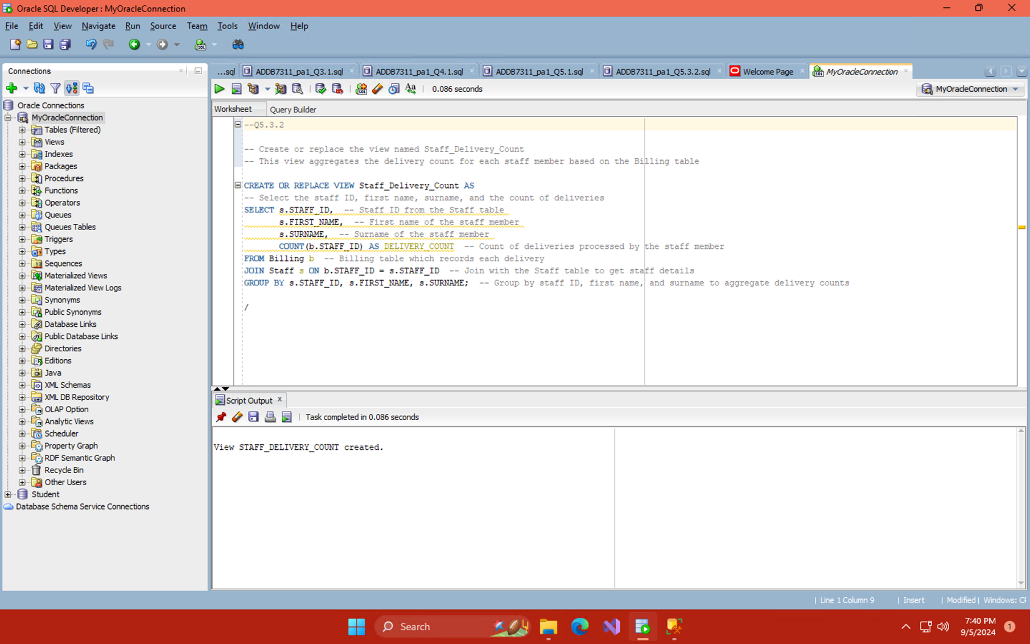

Q6.1

Implicit Cursor Attributes

Motivation:

Oracle uses implicit cursor properties automatically when a SQL statement is run. Without explicitly specifying a cursor, they are helpful for rapidly receiving information about the outcome of SQL operations. This is especially useful for simple actions such as DELETE, UPDATE, and INSERT.

Why Make Use of:

Efficiency: They offer a rapid, non-code method of obtaining information on the execution of SQL statements.

Simplicity: Perfect for basic SQL operations that don't require intricate cursor management.

Automatic Management: Oracle manages cursors automatically, eliminating the need for human intervention.

Explicit Cursor Attributes

Motivation:

When a developer has to handle more complex searches that return numerous rows and needs more control over the result processing, they employ explicit cursors. With explicit cursors, you can control the cursor's lifecycle, which includes opening, fetching, and closing, and get rows one at a time.

Why Make Use of:

Control: Enables row-by-row processing and gives the user more control over how query results are processed.

Complex Queries: Crucial for managing queries that provide several rows and demand complex reasoning to be processed.

Flexibility: Enables management of cursor operations and query result determination by utilising cursor properties such as %FOUND, %NOTFOUND, and %ROWCOUNT.

(simranjenny84, 2022) (Javapoint.com, 2021)

Q6.2 Example Of Implicit Cursor Attributes

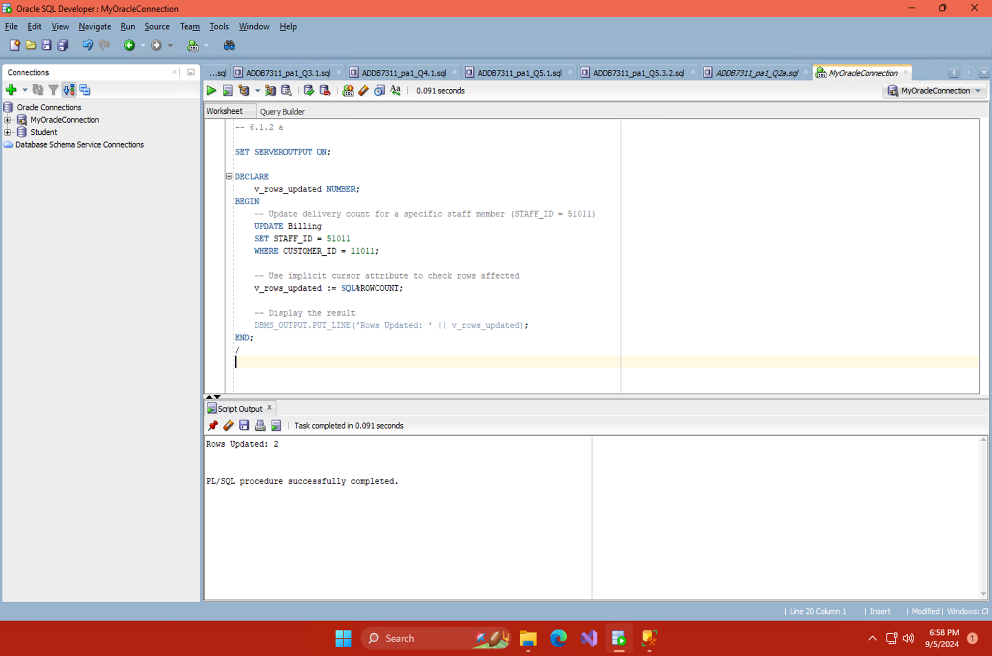

Example Of Explicit Cursor Attributes

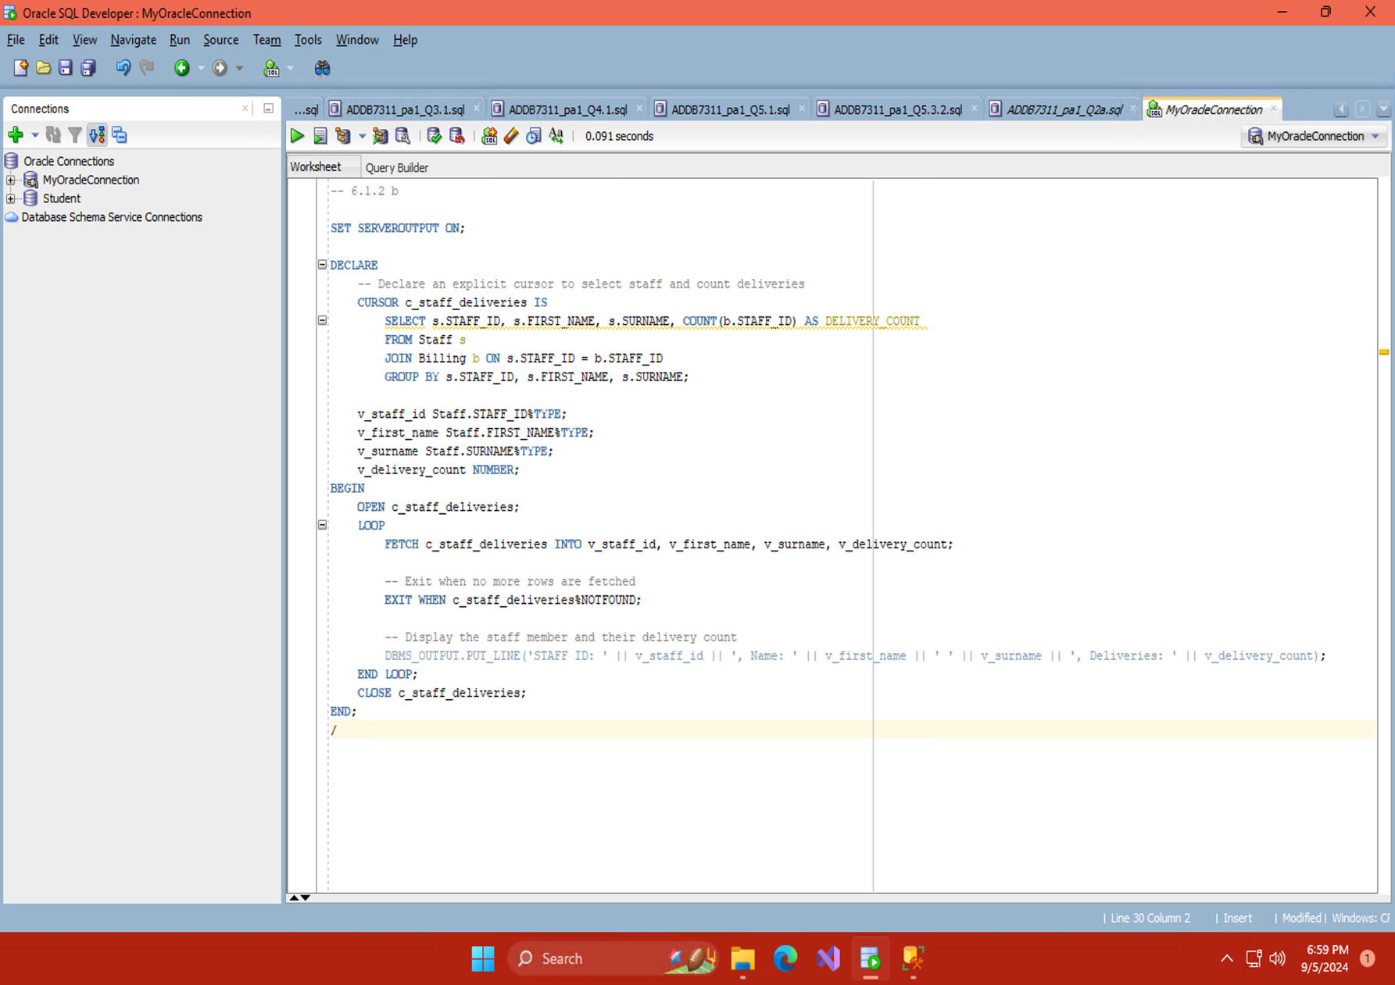

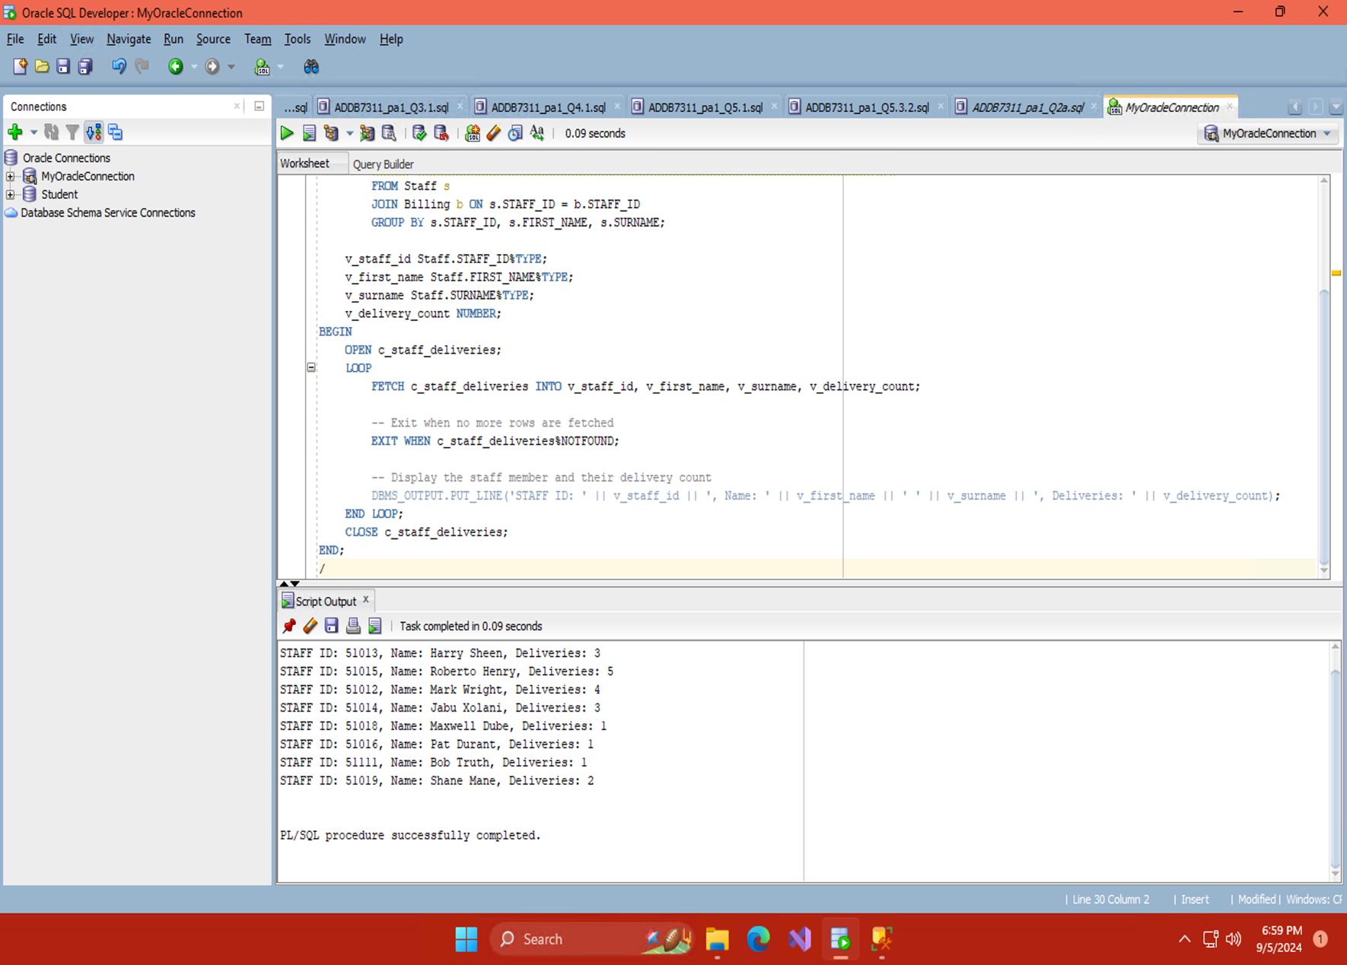

Q6.2 Implementing The Usage Of A Sequence

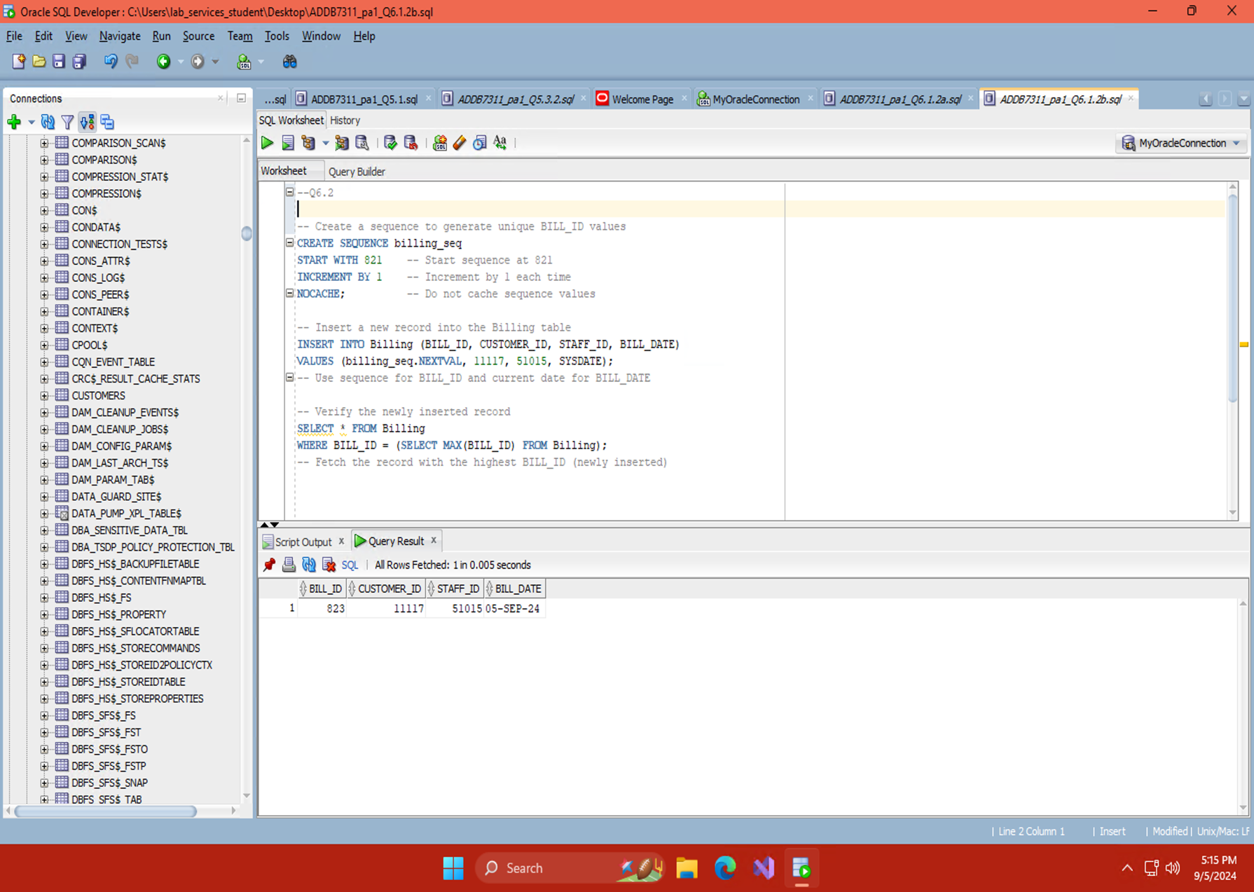

# Bibliography

Imperva, 2024. *Seperation of Duties.* [Online]   
Available at: https://www.imperva.com/learn/data-security/separation-of-duties/#:~:text=These%20separation%20of%20duties%20controls,data%20residing%20within%20production%20systems.

Guldenpfennig, M., 2023. *Study.com.* [Online]   
Available at: https://study.com/learn/lesson/what-is-flat-file-database.html#:~:text=A%20flat%20file%20database%20is%20basically%20a%20giant%20collection%20of,sales%20to%20orders%20to%20invoices.

IBM, 2022. *What is a relational database?.* [Online]   
Available at: https://www.ibm.com/topics/relational-databases#:~:text=A%20relational%20database%20is%20a,key%20or%20a%20foreign%20key.

Hughes, A., Wright, G. & Castagna, R., 2024. *flat file.* [Online]   
Available at: https://www.techtarget.com/searchdatamanagement/definition/flat-file

KHAN, M. I., 2023. *PL/SQL Introduction.* [Online]   
Available at: https://www.geeksforgeeks.org/plsql-introduction/

Navlani, A., 2019. *Views (Virtual Tables) in SQL.* [Online]   
Available at: https://www.datacamp.com/tutorial/views-in-sql?utm_source=google&utm_medium=paid_search&utm_campaignid=19589720824&utm_adgroupid=157156376591&utm_device=c&utm_keyword=&utm_matchtype=&utm_network=g&utm_adpostion=&utm_creative=711801244703&utm_targetid=dsa-

simranjenny84, 2022. *Difference between Implicit and Explicit Cursors.* [Online]   
Available at: https://www.geeksforgeeks.org/difference-between-implicit-and-explicit-cursors/

Javapoint.com, 2021. *PL/SQL Cursor.* [Online]   
Available at: https://www.javatpoint.com/pl-sql-cursor